REACT HANDS ON 4

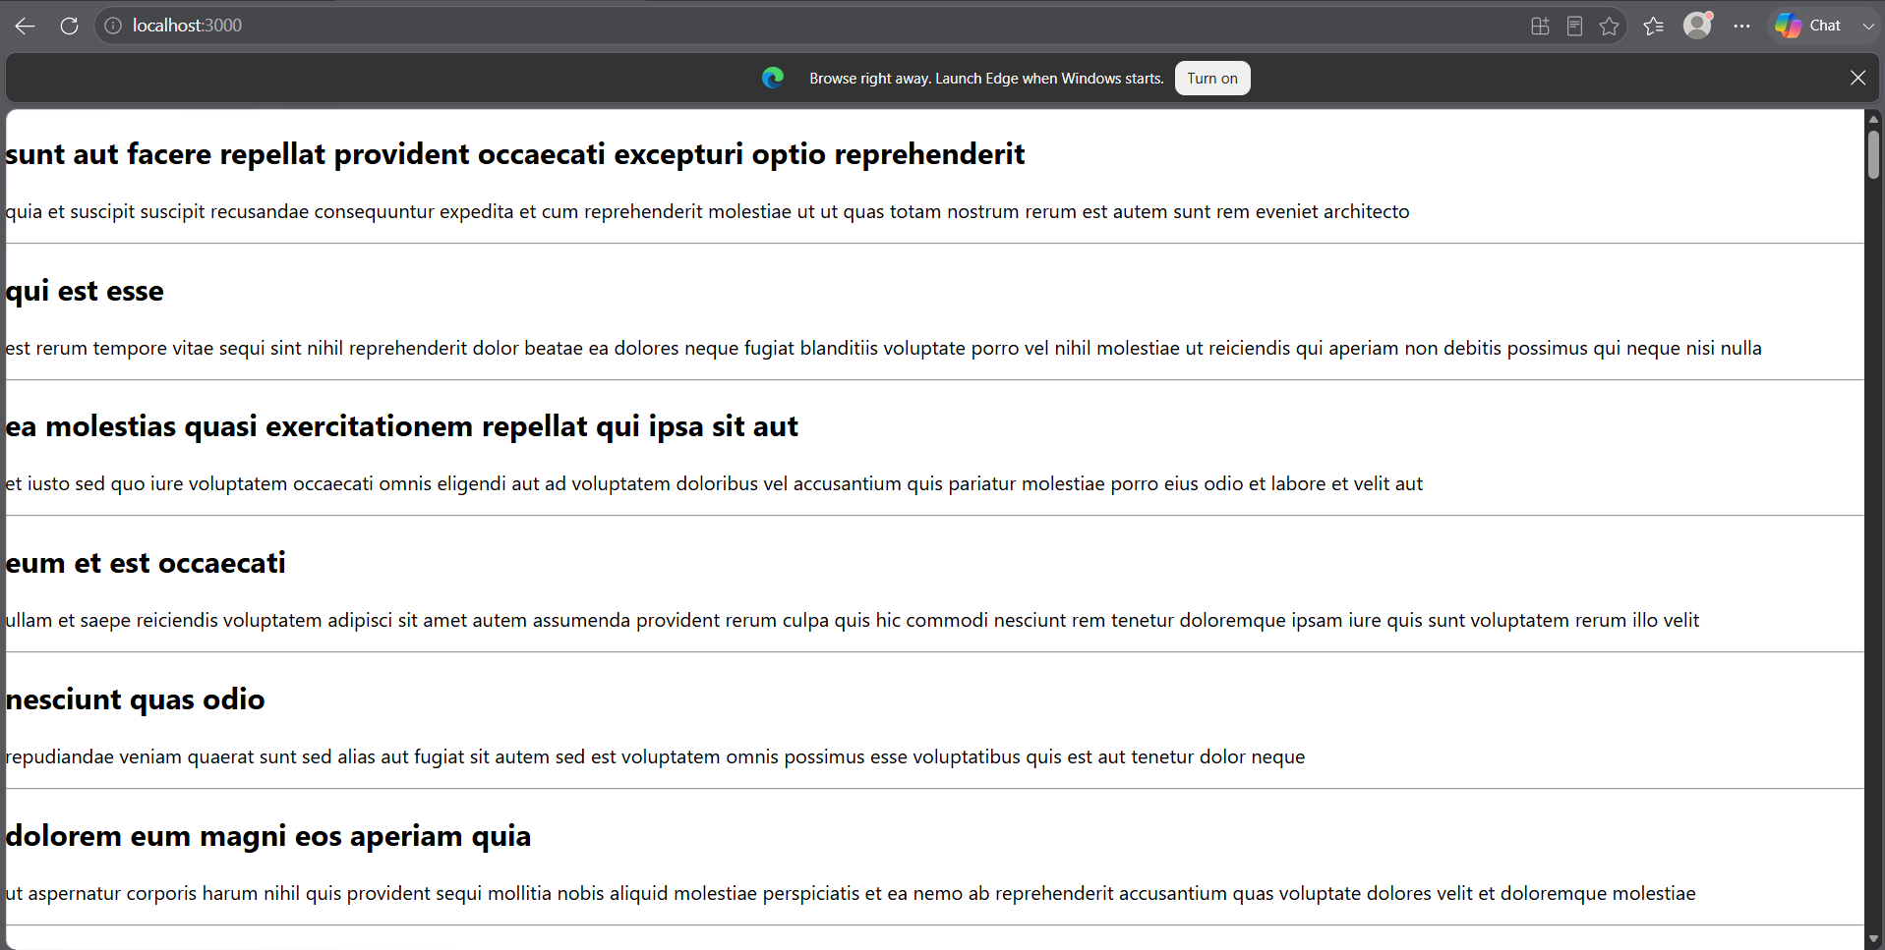

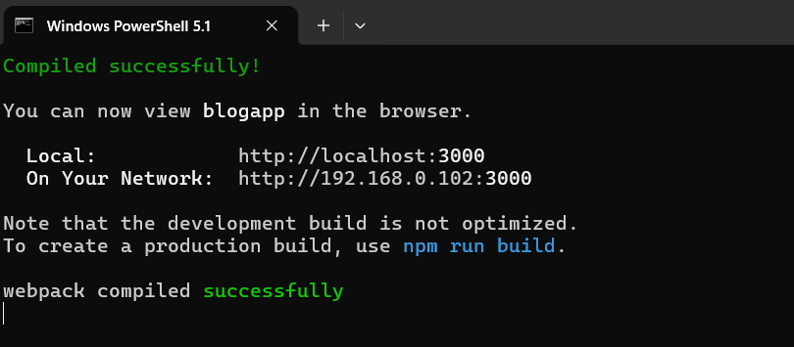

APP.JS
import Posts from './Posts';

function App() {

return (
<div>
<Posts />
</div>
);

}

export default App;

POSTS.JS
import React from 'react';
import Post from './Post';

class Posts extends React.Component {

constructor(props) {
super(props);

this.state = {
posts: []
};
}

loadPosts() {

fetch('https://jsonplaceholder.typicode.com/posts')
.then(response => response.json())
.then(data => {

const posts = data.map(
p => new Post(
p.id,
p.title,
p.body
)
);

this.setState({
posts: posts
});

});

}

componentDidMount() {
this.loadPosts();
}

componentDidCatch(error, info) {
alert(error);
}

render() {

return (

<div>

{
this.state.posts.map(post =>

<div key={post.id}>
<h2>{post.title}</h2>
<p>{post.body}</p>
<hr />
</div>

)
}

</div>

);

}

}

export default Posts;

POST.JS
class Post {

constructor(id, title, body) {
this.id = id;
this.title = title;
this.body = body;
}

}

export default Post;

